# Whitebox Testing

Whitebox Testing is a testing strategy where someone with prior knowledge of a system that the test is taking place in, mostly participated by other individuals in the specified profession or the developer that created the system or program.

## Why it was chosen

Whitebox testing in this instance is the best way for a developer to test their program in the late stages of development, this gives me a chance to test my application in a variety of ways and conditions to ensure that the program functions as expected and intended for the end product.

## Testing Data

This section’s purpose is to test the program in various conditions and grading it on a pass/fail. If a fail were to occur, I would have to correct the bugs.

|  |  |  |  |
| --- | --- | --- | --- |
| Input | Expected Output | Actual Output | PASS/FAIL |
| Enter “Chicken” into the Shopping List | “Chicken” Added to the checked list. | Chicken was successfully added to the Shopping List | PASS |
| Enter “555555555555555555555” To the Shopping List | System hands an error due to too many characters on input. | System throws an error due to surpassing character limit of 20 Characters | PASS |
| Enter A Null Value to the Shopping List | System hands an error due to a null / empty value entered. | System allows a null input into the shopping List | FAIL |
| Enter “Egg” to the Shopping List | “Egg” Added to the shopping List. | Egg was successfully added to the Shopping List | PASS |

## Bug Fixes

Based on my Functionality Testing Above, I had 1 bug to correct in my application, based on the input of a null value. This was fixed by implementing an else if into my input validation function as seen below:

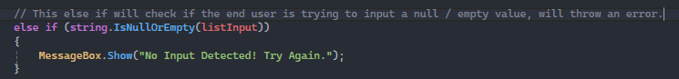

## Updated Testing Data

Based on the bugfixes this is just a simple table to Whitebox Test my bug.

|  |  |  |  |
| --- | --- | --- | --- |
| Input | Expected Output | Actual Output | PASS/FAIL |
| Enter A Null Value to the Shopping List | System hands an error due to a null / empty value entered. | System Blocks User from entering a Null/Empty Value | PASS |